**Visit Snagov Monastery & Mogosoaia Palace**

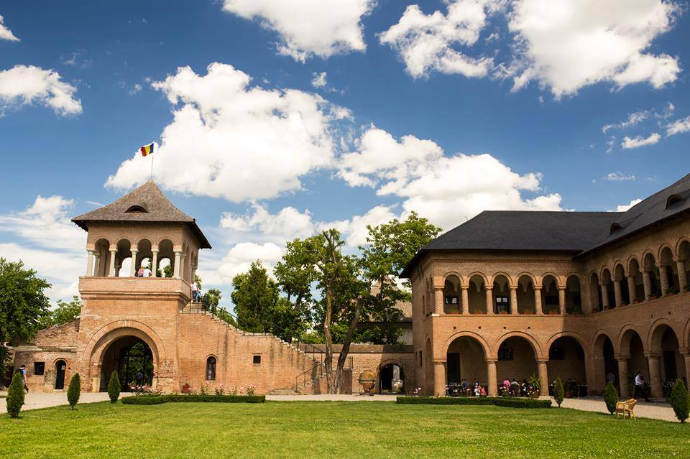

|  |  |  |
| --- | --- | --- |
| TIME |  | TARIF |
| 4 HOURS TOUR |  | **From 39 euro/person** |

***If you’re looking to explore some of the more mystical aspects of this region, then this interesting half-day tour of Snagov Monastery and Mogosoaia Palace is for you.***

**Visit two unique sights in Romania: Snagov Monastery & Mogosoaia Palace**

* Duration 4 hours
* Group size 2 – 15 persons

**Highlights**

* Visit the Mogosoaia Palace and admire The Brancoveanu Style - a unique architectural style created in Romania
* Visit - Dracula’s Tomb in Snagov Monastery - a 14th-century monastery located on the island in the middle of Snagov Lake

**Description**

This fascinating tour of Snagov Monastery and Mogosoaia Palace is an amazing opportunity to admire two of Romania’s most unique sights, which are within easy reach of nearby Bucharest, although a million miles away in terms of ambience.

First up is a tour of Snagov Monastery, which is a 14th-century religious site located on an island in the middle of Snagov Lake. Alleged throughout myth and legend to house Dracula’s tomb the monastery is a peaceful oasis surrounded by fresh air and a lovely park, but prepare yourself because intrigue and adventure lie in wait throughout this tour of Snagov Monastery. The calming air of the monastery’s grounds is a million miles away from the hustle and bustle of vibrant Bucharest, and you will feel at ease as you explore its many fascinating features.

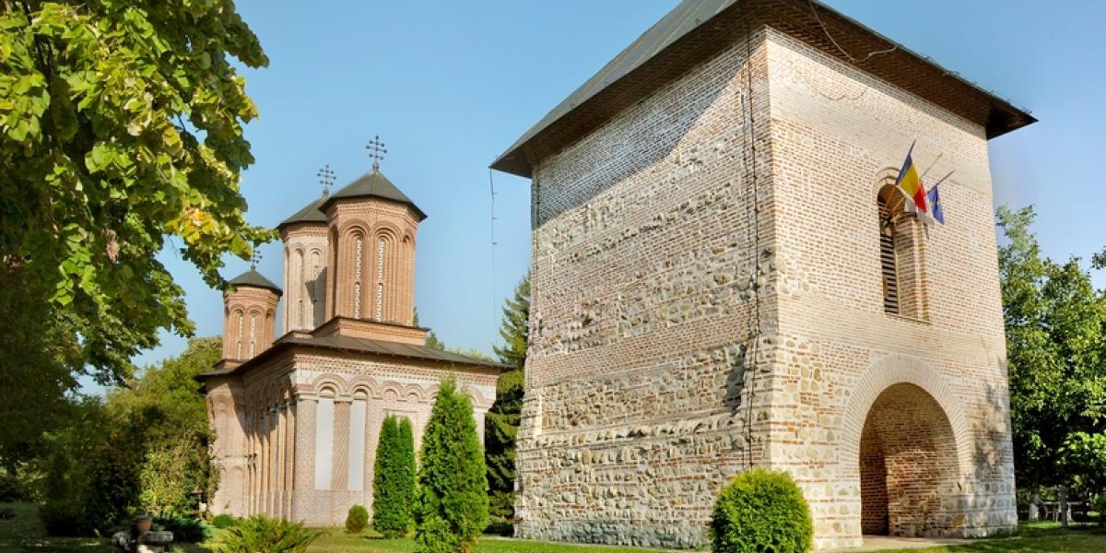

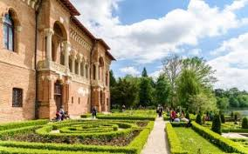Following your journey into history, you will head over to **Mogosoaia Palace**, during which you will be able to explore its spectacular gardens and delight in its unique Brancoveanu style of architecture, which blends Venetian and Ottoman elements. This is the Romanian Renaissance at its finest, and you will learn so much during your guided tour. The grandeur of Mogosoaia Palace will leave a lasting impression, and located just 15km from the city center it’s a convenient and stunning attraction.

**Includes**

* Entrance ticket for the Mogosoaia Palace and Snagov Monastery
* Pick-up from your accommodation in Bucharest
* Professional tour guide
* Round-trip transportation

**Extra**

* Pick-up time may be different from the departure one
* A minimum of 2 participants is required to organize the tour
* Lunch
* Photography & Video fees

**PRET 39 EURO**