**AUTUMN IN THE DANUBE DELTA**

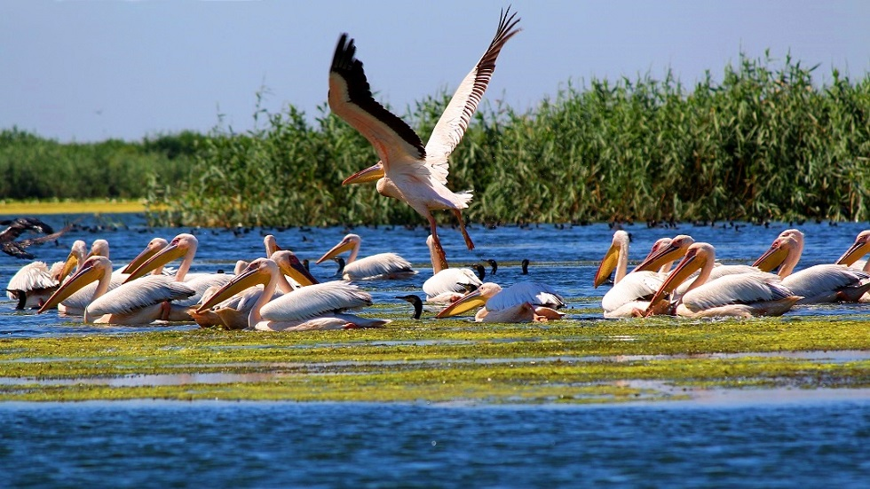

**175 EURO/ pers in double room**

|  |  |
| --- | --- |
| DATE | NO. NIGHTS |
| 14-16.10.2021 | **3 days / 2 nights** |

*The Danube Delta is fascinating at any time of the year. Each season has its charm to be discovered by visiting this exotic land, this heaven of birds and fish.*

*The Delta is a refuge for wildlife lovers, bird watchers, fishermen and anyone who wants to move away from the city in a dream area for a few days. There are beautiful beaches, secluded both in Sulina and Sfântu Gheorghe, and the fish and especially the fish soup, are the best in Romania.*

*Listen to the noises of nature, the rustling of the reeds in the boat rides on the canals and lakes of the Danube Delta, admire the beauty and grace of the birds that arrow the endless blue stretches and then you will begin to identify with this wonderful place.*

**THE TARIFF INCLUDES:**

* transport Bucharest – Danube Delta and return with buses classified for domestic and international transport;
* 2 nights’ accommodation pension 3 * - LUNCA / similar in double / triple rooms
* accommodation with half board (2 breakfasts and 2 dinners)
* authorized guide
* visit to the main attractions in the area and to the objectives proposed in the program;
* fun and good cheer
* **BONUS! Welcome dinner with traditional music**
* **BONUS! LATINO MUSIC SHOW**

**THE TARIFF DOES NOT INCLUDE:**

* entrances to the tourist attractions in the program;
* delta permits – 1 euro/pers/day
* boat ride – 20 euro
* wine tasting at a Dobrogea wine cellar – 15 euro
* personal expenses
* lunch
* single room supplement: 50 euro/pers;
* **ACCOMMODATION:** enter the accommodation with dinner and go out with breakfast; pension 3* - LUNCA

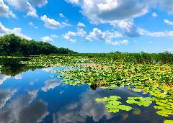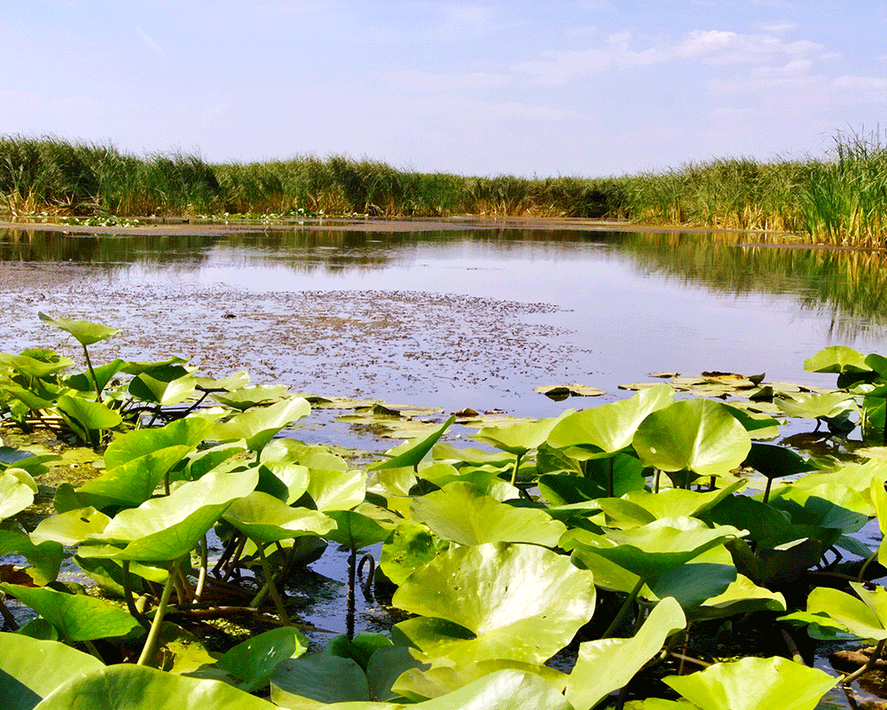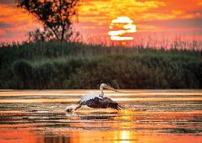

**EXCURSION SCHEDULE**

* **DAY I: BUCHAREST – TULCEA – LUNCA (approx. 370 km)**

Meeting approx. At 06:00 departure 06:30 in the morning from Bucharest Constitution Square.

Following the given route, we make a stop at **the Ecotourism Museum Center ''Danube Delta'' in Tulcea** and at **Enisala fortress.**

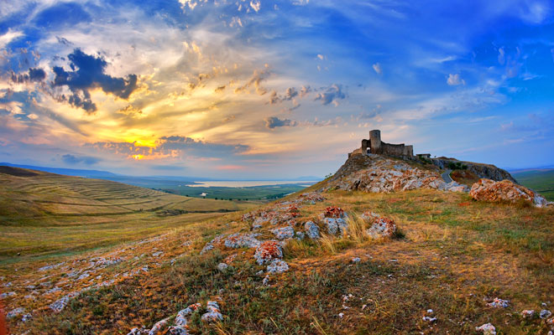In the evening we arrive at the hotel accommodation / pension 3 *, accommodation and dinner of welcome and traditional music.

* **DAY II: boat rides and visit to Halmyris Monastery and Halmyris Fortress (approx. 10 km)**

After breakfast we visit **the Halmyris monastery and the fortress with** the same name **in** the **afternoon** **at** sunset we go on a boat trip to the Danube Delta. We return to accommodation, traditional dinner, music and dance. **BONUS! Latino evening!**

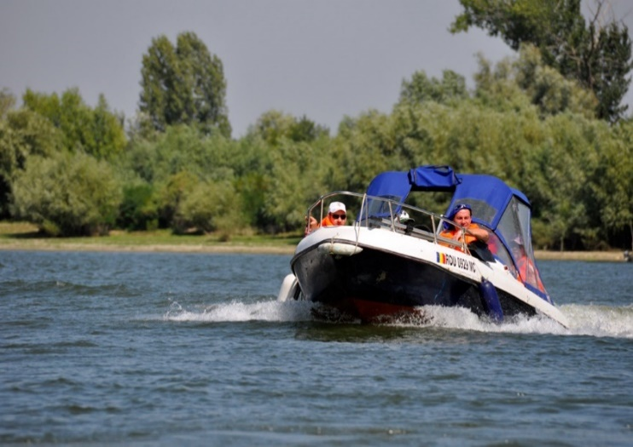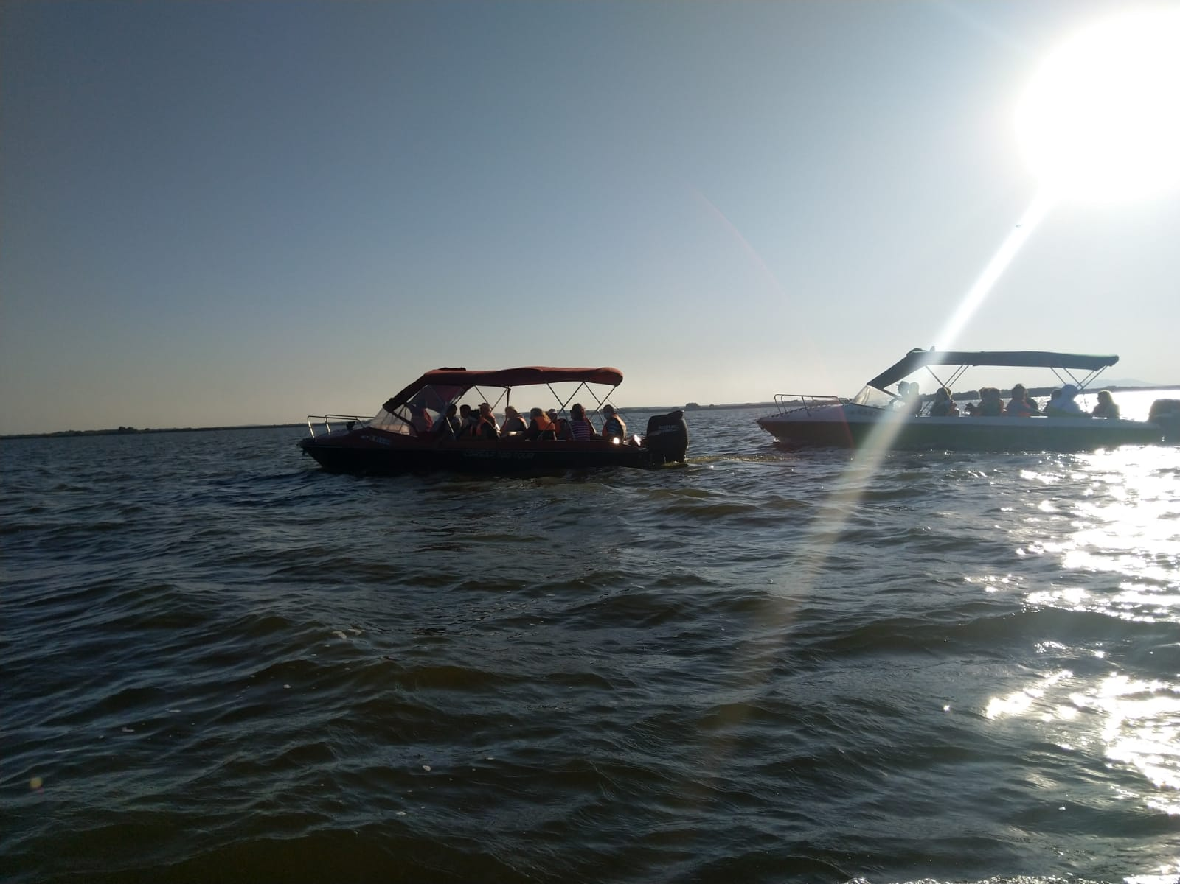

* **DAY III: DOBROGEA MONASTERIES - DOBROGEA WINE CELLARS - BUCHAREST (approx. 450** km**)**

After breakfast we visit [**the Celic Dere Monastery**](https://www.crestinortodox.ro/reportaj/72344-icoanele-unicat-de-la-manastirea-celic-dere)  **and the Cocos Monastery.**

**Visit to the Dobrogea wine cellar with tasting (for 5 wines - price 15 euro / pers).**

We then head to Bucharest where we arrive around 20:00-21:00 depending on the traffic and weather conditions.

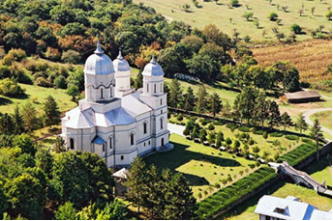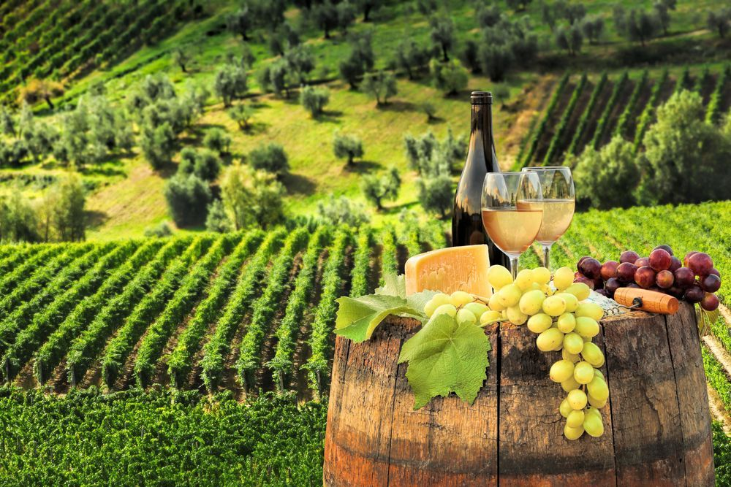

**ACCOMMODATION: CASA PESCARILOR LUNCA 3\***

**Situated between the waters, in a fairytale setting, Lunca Fishermen's House represents a true oasis of tranquility and relaxation. The pension is open all year round, and most tourists opt for this location in** [**autumn**](https://discoverdobrogea.ro/delta-dunarii-este-spectaculoasa-si-toamna-peisajele-sunt-de-basm-iar-pe-canale-nu-se-mai-circula-ca-pe-bulevard/)  **and even winter, either because of the recommendations made by other visitors, or because they can get to the pension by car.**

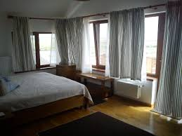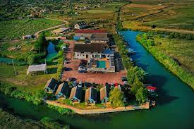

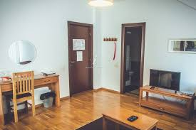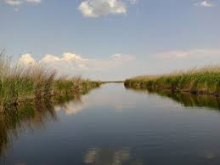

**NOTE:**

**The daily schedule and the order of visits may change, fully respecting the visits mentioned in the program.**

**The category of hotels and means of transport is in accordance with local norms.**

**The price is calculated at a minimum group of 40 people**

**The rates are valid for the above conditions. Changing the period, the number of participants or other conditions also entails changes to the offer.**

**The group leader reserves the right to organize the visits from the program according to the weather conditions, local objective situations, traffic.**