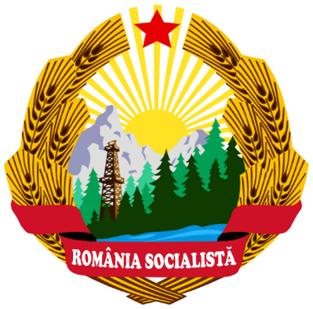

ROMANIA COMMUNISM TOUR

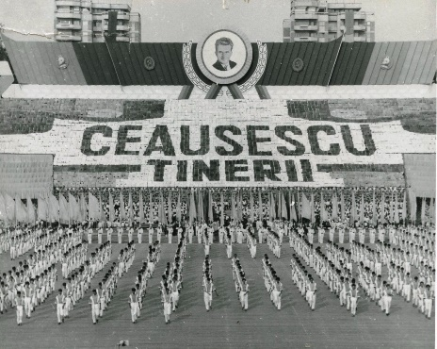
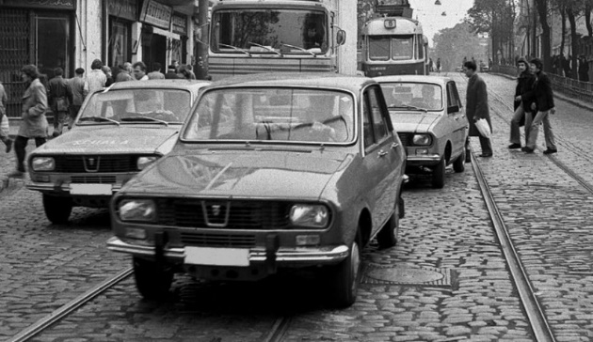
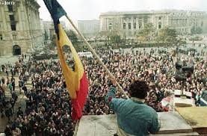

Romania was a communist country for more than 40 years, between 1948 and December 1989. Nicolae Ceaușescu became general secretary of the Romanian Communist Party in 1965 and president of the Socialist Republic of Romania in 1974. 15 years later, he was dismissed from power and executed after a violent revolution in the winter of 1989.
In this experience you will have the opportunity to observe the strong imprint left by communism on the entire Eastern Bloc, even after the fall of the Iron Curtain.
Even though 30 years have passed since the last dictator of Europe, Nicolae Ceausescu, was removed from power, the traces of communism in Bucharest are still visible throughout the city.
This tour of communist Bucharest will take you through the remains of the glory period of Romanian communism. You will visit the neighborhoods that were built for the working class, you will walk through Piata Revolutiei (Piata Unirii and Piata Universitatii), you will discover the grandeur of the Parliament Palace and you will take a tour of the Spring Palace, the place where the Ceausescu family lived their luxurious life .
Follow us on this journey through Bucharest to reveal the "great achievements of the golden age" and hear the story of the people who built it. You will see the first communist building in Bucharest, Revolution Square with the balcony where the dictator gave his last speech, the majestic "People's House" and the former residence of the presidential couple.

Route:
The itinerary of the Communist Tour in Bucharest will include:
Old Center –Victoria Road - Revolution Square (Romanian Athenaeum, Revolution Memorial) –Palace of the Parliament – ​​Unirii Square – Spring Palace (former residence of the dictator) – Arc de Triumf – Free Press Square
How is the experience going?

Day 1 - Bucuresti

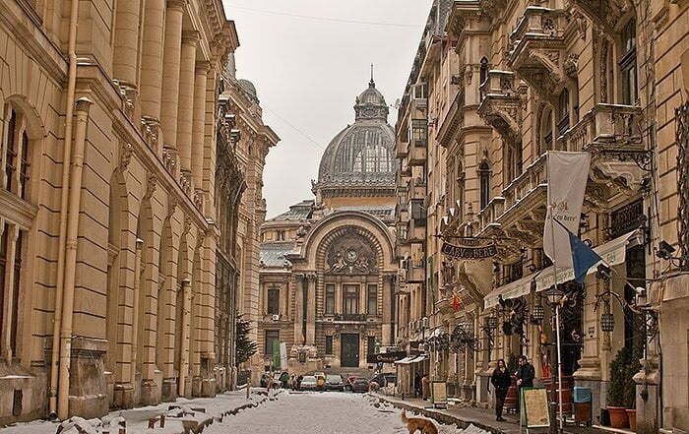
The city tour starts at 10:00, after the guide will pick you up from the hotel or from a point in Bucharest. The first stop is at the subway. It was built starting in 1979. Spoiler alert: the subway stations were painted in the party's common colors: red, white and gray.
Bucharest is known as the "city of contrasts", especially for the strangely combined different architectural styles. Then you will visit the Old Center.

In the first years of communism, starting with the 1950s, the Old Center of Bucharest survived, and the party did not want to change it. Later, architecture was used as a propaganda weapon for Romania to identify itself with other communist countries, such as North Korea or China.

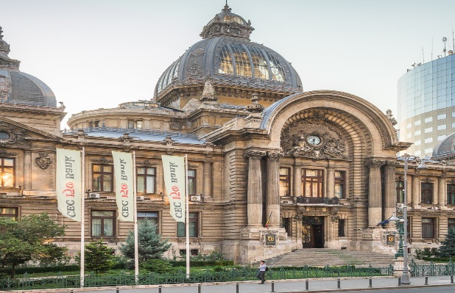
We will visit Calea Victoriei where we can admire some impressive buildings such as the National History Museum, the CEC Palace, the National Military Circle and Casa Capsa.
The architecture of Bucharest began to change, especially during the reign of Nicolae Ceausescu, after he and his wife, Elena, visited North Korea and China in the early 1970s. The dictator, passionate about architecture, but without any talent, mutilated capital city. In order to build the Palace of the Parliament, Bucharest lost historical buildings in a teritory of the size of Venice.

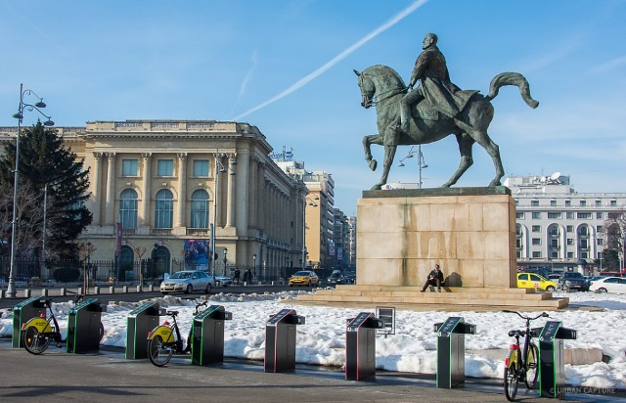
After the visit on the Victory Road, you will head to Revolution Square, the place where Ceausescu fell and, with him, communism. The Communist Party gathered the factory workers in the Square for a rally for the party, but, unfortunately for them, this is the moment when the anti-communist revolution began.

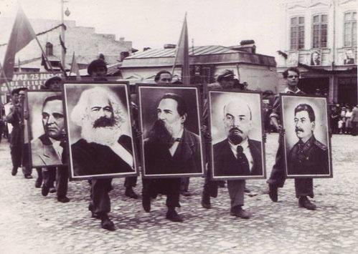
We will go to visit the Museum of the Horrors of Communism in Romania - which commemorates the crimes and atrocities that took place between 1945 and 1989 in Romania.
The museum analyzes the communist regime stage by stage and shows the experiences of the victims of the communist regime

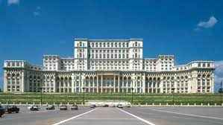
The next stop on the tour is at the Palace of the Parliament - the second largest and heaviest administrative building in the world. Named, initially, the House of the Republic, this is Ceausescu's most spectacular project. The architect who designed and built the palace was only 28 years old at the time, and some say that the main reason why she won the competition is that her project was the grandest.
(It takes 1,5 h - 2 hours to visit inside).In our tour we propose outside visit of the Palace)
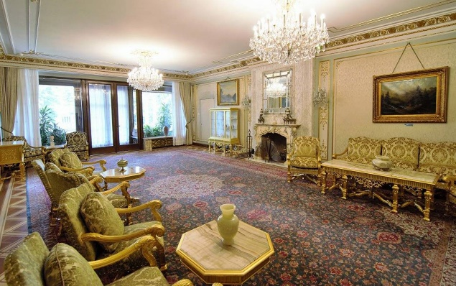
The next landmark of the tour is the Spring Palace - Ceausescu's residence. This luxurious property was finished in 1965, the year he became first secretary of the party. After the fall of the communist regime, the Spring Palace was used as a residence for official delegations and presidents, and in 2016 it was transformed into a museum.

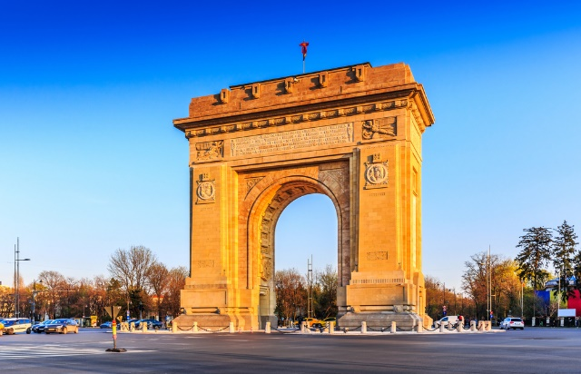
Arc de Triomphe – a symbol of victory
The Arc de Triomphe is a special type of monument, the meaning of which is the highest form of commemoration of historical events and personalities. Its gate-shaped specificity allows the triumphant passage of the personalities thus honored under the monument's arch.

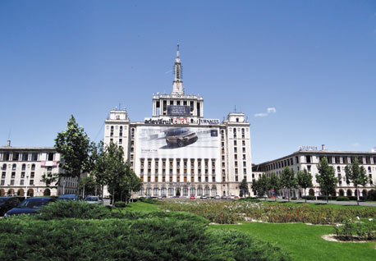
Casa Presei Libere, also known as Casa Scânteii, is one of the most representative buildings in Bucharest, Romania. It was built between 1952-1957 and initially served as the headquarters of the Romanian Communist Party and the media controlled by it.
The Casa Scânteii building is distinguished by its modernist architecture and its impressive dimensions. It has a height of 91 meters and an area of ​​approximately 32,000 square meters. Its design was inspired by Soviet architecture, especially Berlin's Stalinallee (today Karl-Marx-Allee). The construction is a reduced-scale copy of the "Lomonosov" University building (built between 1949-1953) and the "Leningrad" Hotel, both in Moscow.

The communist Bucharest tour will end with a traditional dinner with dancing and good cheer, and your tour guide will transfer you back to the hotel or the point from which you left.
Accommodation will be at Hotel Minerva ****, located in Old Center.

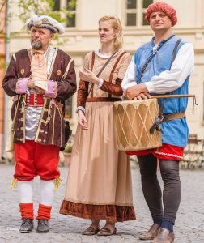
Day 2 – Sighisoara

Breakfast of the Hotel Minerva, check out from the hotel and we leave towards Transylvania Region.On the way we will stop in Brasov the charming medieval city in Carpathians Mountains, short tour and free time for lunch.Then we leave to Sighisoara Fortress.
We start the tour guided by the drummer of the fortress – our guide Sighisoara Medieval City.

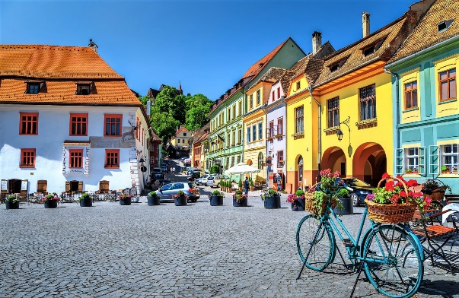
The heart of the Sighișoara fortress is represented by the Cetății Square. In the past, it was a place full of activity and hustle and bustle, because, here, lawsuits were judged, the inhabitants traded and the most important announcements for the community were made. The citadel was included in the UNESCO World Heritage and has 9 towers, which were included in the tour of the fortifications in Transylvania.

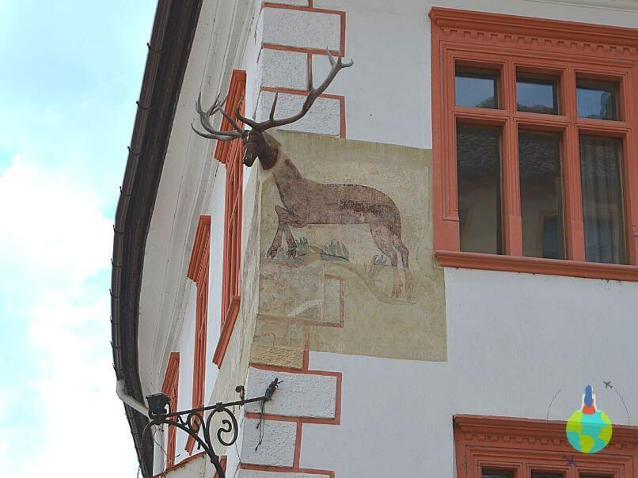
Also in Piața Cetății we find the "Deer House", perhaps the most interesting building from an architectural point of view. The name and uniqueness is provided by the exterior mural, which represents a life-size deer. The stag has its head and trophy mounted directly on the wall.

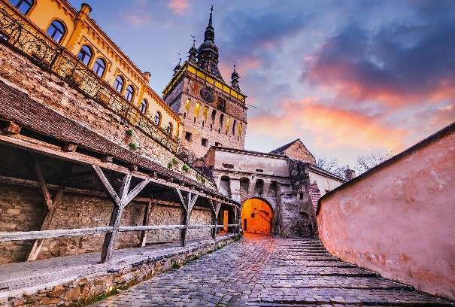
Low and towering, the Clock Tower is the most important monument for the Citadel of Sighisoara. The tower, 64 meters high, dominates the two squares of the Upper Town and the Lower Town. It is the only tower of the Citadel, which did not belong to any guild. Being the headquarters of the City Council, it was in the custody of the public authorities.

In the medieval period, Sighișoara Citadel was a city with many rights granted by the king. Among them was the "jus gladii" right, that is, the city administration had the right to judge and sentence criminals to death in the name of the king.

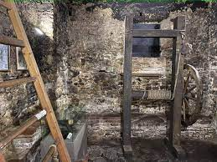
In the past this was the city jail. It was the most feared place in the city. At that time, the punishments for those considered "wicked" were among the most terrible: women suspected of witchcraft were burned at the stake, those who stole lost their hand, criminals and those who committed adultery were sentenced to death. The instruments of torture on display in this room help us to get an idea of ​​the extraordinarily cruel manner in which the interrogation was carried out. Many times, people accepted their alleged guilt, just to escape the terrible suffering caused by torture. Among the most common tortures were hanging a 6 kg stone around the neck and tying the defendant to the "post of infamy" to be mocked.

We will head to Sighisoara where we will stay at the accommodation.
Accommodation will be at Casa Wagner 3 *** hotel, or similar centrally located right in the heart of Sighisoara citadel.

Day 3 – Cluj-Napoca

Breakfast of the hotel, check out from the hotel and we leave at Cluj-Napoca.

In Cluj we will do the 1989 Revolution Tour is a free educational project that presents the story of those who faced the tanks and bullets with their bare hands to overthrow the communist dictatorship. The route includes the important points of the era: the conspiratorial house of the Security, the Communist Party County Hall, the Victoria Hotel . , Mihai Viteazul Square and the city center.

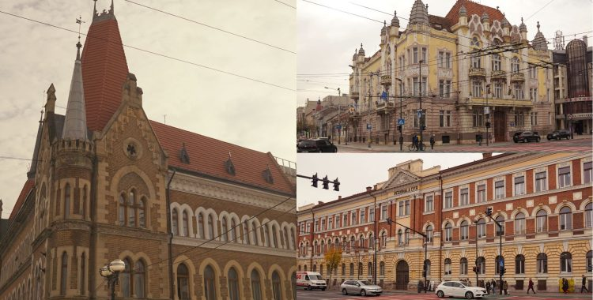
The current headquarters of the Prefecture has been used throughout history for various activities: the headquarters of the Communist Party, the City Hall or, after the revolution of 1989, the headquarters of the Cluj County Council.

The headquarters of the Communist Party - After the Second World War, when the communist system imposed itself in Romania, it was the City Hall and then the county headquarters of the Romanian Communist Party. After the events of 1989, it became the seat of the Prefecture and the Cluj County Council.

Another building full of history is also the headquarters of the current one Victoria Hotel. Opposite the headquarters of the Romanian Communist Party in the functional Prefecture building, the Victoria Hotel was the building of party activists.
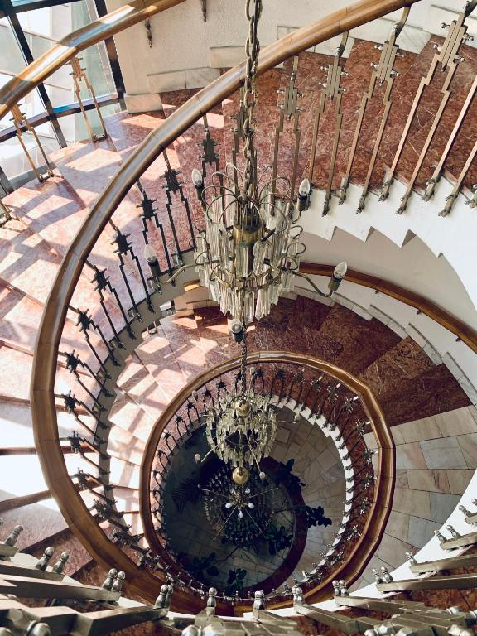
The current Victoria Hotel was the Party Hotel. It was built in 1984-1986. It was intended for party activists. At one point the building of the current Prefecture was painted in the original colors and the building of the hotel for party cadres.

Going further from the Prefecture towards the city center on the right side, in the building where the Orange company operates today, is the blue building, the former financial barracks.
"The blue house on 21 Decembrie Boulevard was called the Financial Barracks. All the officials working at the Ministry of Finance lived in this house built at the beginning of the 20th century.

Maghiarilor Street - In the past, the current 21 Decembrie Boulevard was also called Lungă Street.
Because the old center - the ovár - i.e. the current Museum Square and the adjacent area was predominantly inhabited by Saxons, a Germanic population. This does not mean that there were not others. And this part (in front of the Prefecture) that was outside the walls was called Maghiarilor Street. It was a majority Hungarian population. It was also called Lungă street. Until the 17th - 18th century, buildings outside Cluj had to be built at an appreciable distance from the city walls. That's why this area where we have Ştefan cel Mare Square and the Orthodox Cathedral were empty lands or pastures. They were not allowed to build. It was later built in the 19th century," explained the history teacher.
Imperial officers and very rich Armenian merchants are buried in the current Church of the Transfiguration on Heroil.

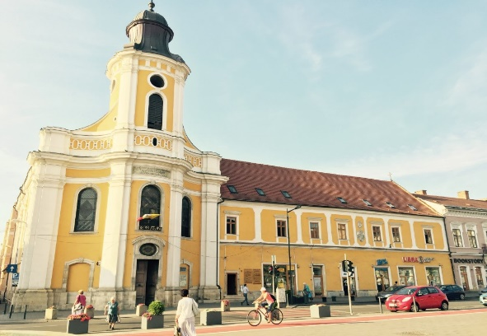
The Church of the Transfiguration in Cluj-Napoca was built at the end of the 18th century and was done wrong. Her tower is collapsing. After a period of several years under the sponsorship of the empress Maria Tereza and with the help of a great architect, the church tower is a restaurant and in the sea it looks like it does now. It was a Roman Catholic church until 1924 when the Pope of Rome offered it to the Greek Catholic cult. There was a big scandal, but in the end, the administrative center of the Greek-Catholic church from Gherla is moving here. In 1948, when the Greek-Catholic cult was outlawed, the church passed to the Orthodox. Until 1998 it belonged to the Orthodox cult and by a court decision it belongs to the Greek-Catholic cult. Here is a crypt where imperial officers of the empire and rich Armenian merchants are buried. The Armenian population here in the city in its great majority became Hungarian. The Armenians being very rich were buried in the crypt in this church.

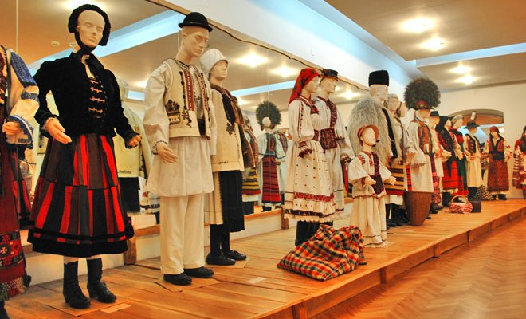
The Ethnographic Museum of Transylvania is a museum in Cluj-Napoca (Memorandului str. no. 21). The museum was founded on June 16, 1922, being one of the cultural achievements of the period following the Great Union of December 1, 1918. With a century of uninterrupted operation, the museum is the oldest of its kind in Romania and one of the most prestigious in Europe .
The museum has a heritage of over 100,000 pieces of folk wear and testimonies of various ancient customs, reflecting the occupations of the Transylvanian population. They are rigorously organized, offering visitors a complete picture of Transylvanian customs. The museum's heritage is organized into 8 sections: Ceramics, Textiles, Occupations, Port, Housing-Food, Customs, Open Air Section and International Section. There are 50,000 photos; 5,000 slides; 12,000 specialized magazines.

We will leave for Cluj-Napoca where we will spend the night at the 3 *** Hotel Victoria, located in the city center.

Day 4 – Timisoara

Breakfast of the hotel, check out from the hotel and we leave at Timisioara.

The tour starts in Piața Maria, where the Revolution started, and goes through all the locations where important events took place. Among many other information, you will also learn about the evolution of communism, how life was back then, how the communists managed to get involved in all the activities of the population and much more.

The Memorial of the Revolution is the final point of the tour where we will be able to learn more about what happened and even see a piece of the Berlin Wall. Among the important monuments are: the Monument to the Romanian Soldier, in the Central Park, the Monument to the Fallen Heroes in the Second World War, or the Monument dedicated to the Yugoslav soldiers, the Anti-Communist Resistance Monument.

The monument, erected 25 years ago in memory of those who resisted and sacrificed themselves in the fight for freedom, was restored and completed with new elements that emphasize the diversity of the forms that the anti-communist resistance took in the period 1945-1989 .
Many former political prisoners and deportees and their descendants took part in the event. From the Memorial of the Victims of Communism and the Resistance.

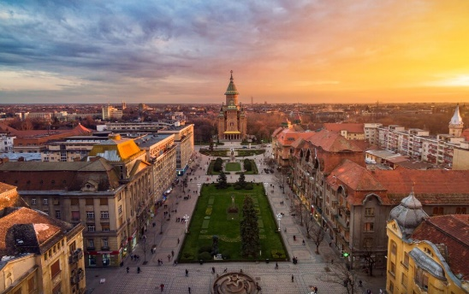
Piața Victoriei - The newest market in the Cetate neighborhood is today the center of the city. The story began with the defortification of Timisoara (in the first decades of the 20th century), when a boulevard was designed and built that existed until the end of the 1980s. Beautiful palaces in the style of the 1900s were built at a dizzying speed between 1910 and 1914. One of the first tram lines in Europe operated here until 1987. The two long sides of the square were the local people's promenades: the left side (as you look towards the Cathedral) was called "Surrogate," and the right side was called "Corso" and represented the place for the "good world" who wanted to walk.
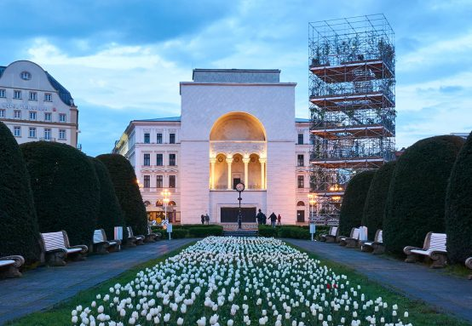

Palace of Culture - Probably the most emblematic building in Timișoara. It was built between 1872 and 1875, in the Neo-Renaissance style, according to the project of the Viennese architects Helmer and Fellner. The building was damaged by fires in the 1890s and 1920s. During the second restoration, the hall was decorated in a non-Ormanian style. In the 1930s, the Bucharest architect Duiliu Marcu restored the main facade in the form of a triumphal arch.
In 2003, the main facade was restored to its current form. After the Revolution of 1989, the balcony of the building has a strong historical significance, being the place from where Timișoara declared itself the first city in Romania free of communism. The building now houses four cultural institutions: the National Theatre, the Romanian Opera, the German Theater and the Hungarian Theatre.

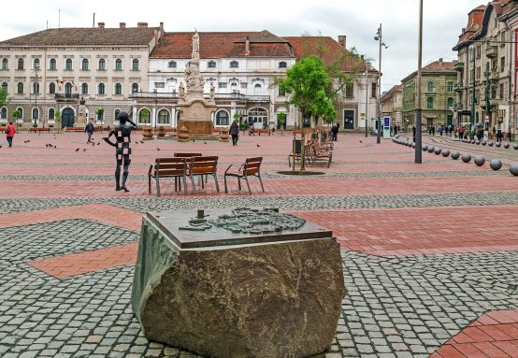
Freedom Square - Over time, the appearance of the square has changed. During the Ottoman period, it housed the public baths, the bazaar and the great granary. The ruins of the baths were excavated in 2014, and the outlines of the walls and pillars that supported the floor are marked on the pavement of the square and can be easily identified during a walk. The configuration of the square that we see today dates back to the 18th century, during the Habsburg period, when it was called Paradeplatz (Parade Square) and was the administrative center of the city. Not by chance, the Old Town Hall is located on the north side of the square. The square has recently been renovated and has been transformed from a densely vegetated square into an event square. It now hosts outdoor shows and concerts, the Christmas Market, as well as terraces and rest areas.
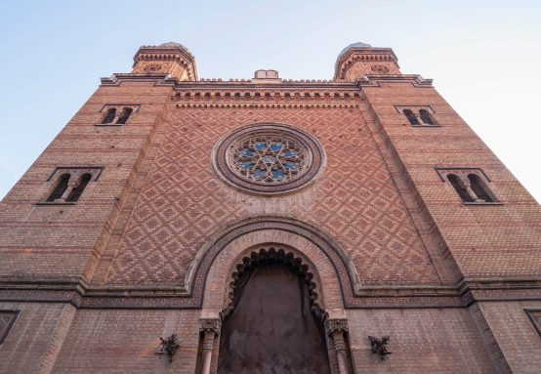
Citadel Synagogue - In the middle of the 19th century, after more than a century of restrictions and discrimination, the Jewish community receives approval to build a new synagogue. The project is entrusted to the architect Carl Schumann, a disciple of Ludwig Förster, the architect of the Budapest synagogue. The synagogue is inaugurated on Rosh Hashanah (New Year's Day) in 1865. Seven years later, the synagogue is reopened during the visit of Emperor Franz Joseph, one of the main donors. The synagogue, which had fallen into an advanced state of disrepair in the early 2000s, was renovated and reopened to the public in 2022. It is now a meeting place for the Jewish community and host to cultural events.
Piața Unirii - The square, built by the Habsburg administration in the first half of the 18th century, was originally lined with buildings of no more than one storey, giving it a rather provincial appearance. In the 19th century, a few two-story buildings appeared, and in the early years of the 20th century, three-story buildings were built, some of them in the Art Nouveau style. Among the square's Baroque buildings, the Roman Catholic Cathedral and the Baroque Palace are noteworthy. The presence of the Serbian Orthodox Church, alongside the Catholic one, is proof of the climate of tolerance for which Timișoara is famous. Today, the square is the liveliest place in the city, with lots of welcoming terraces and carefully restored facades with vivid colors.

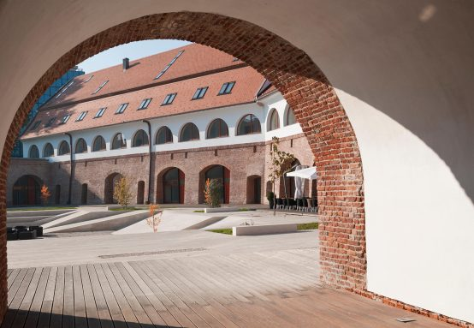
Bastion Maria Theresia - It is the only one still standing today of the nine original bastions of the Vauban fortress, built between 1732 and 1765 by the Habsburg administration. The bastion housed the "provision" (food store) and the gunpowder store. The fortress had a star shape in plan, the nine bastions representing the corners of the star, three rings of fortifications and two water ditches. It was attacked only once, during the Revolution of 1848, resisting the siege that lasted 107 days. It now houses cafes and restaurants, cultural spaces and sections of the Banat Museum.

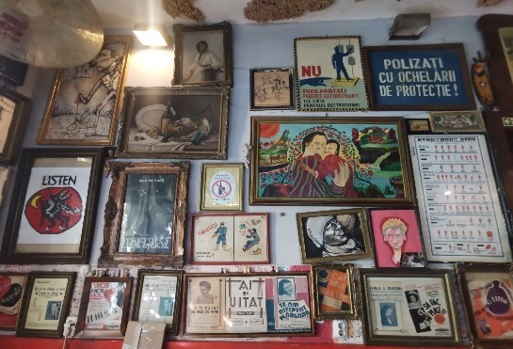
The Museum of the Communist Consumer in Timișoara is a private initiative of Ovidiu Mihăiță and was established in 2015. The museum has no political or ideological character, but aims to preserve memories and a fragment of history. Arranged inside an apartment in an old building in Timișoara, the museum exhibits all kinds of defining objects for the communist period, which Romanians had at home (furniture, electrical appliances, trinkets, toys, records, books, objects specific to that period).

We will head to Timisoara where we will stay at Hotel Central 3 ***or similar.

Day 5 – Sinaia

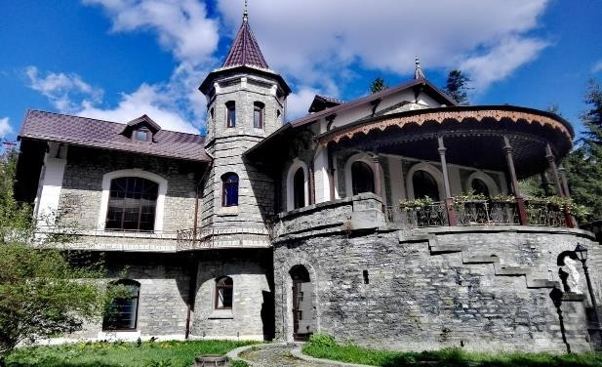
We will leave for Sinaia to continue the communist tour where we will visit:

Știrbey-Florescu Castle, the oldest holiday residence in Sinaia, houses the Sinaia City Museum, a place where local stories and historical data meet in a unique and modern design concept.

Știrbey Castle is under the signature of the Dutch architect Josef Jacob Schieffleers, and is made up of 13 thematic rooms that invite you to discover the secrets of the city,
We will stop to serve lunch and then continue our tour.

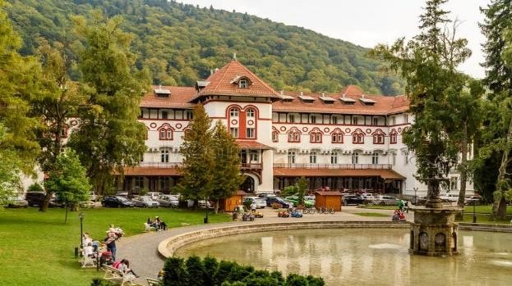
Dimitrie Ghica Park in Sinaia, was established in 1881 and is a place of recreation that offers visitors several attractions.

On the side of the alleys that cross the park, there are busts of personalities who lived or just visited the city of Sinaia, such as, for example: Mihai Eminescu and lon
Creangă, Nicolae Bălcescu as well as Dimitrie Ghica.

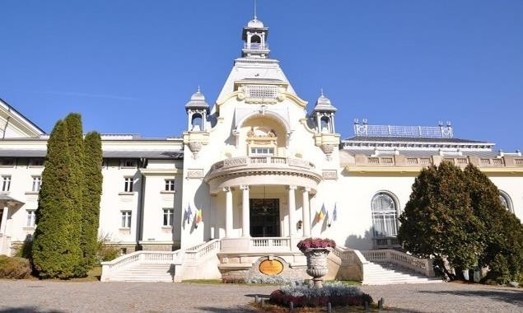
The Sinaia Casino is located in the "Dimitrie Ghica" park and was built at the initiative of Carol I. It has become a tourist attraction of the city of Sinaia,
and its strong point is the over 500 works of art in the art gallery and in the character exhibitions temporary.

The donations of the painters Augustin Costinescu, Mihail Gavril, Bogdan Mihai Radu are remarkable, but even the temporary exhibitions do not bear the signatures to be neglected: Cornel Vana, Calin-Raul Anton, Rares Kerekes.

We will head to Sinaia where we will stay at the accommodation.
Accommodation will be at Hotel 3 *** hotel, centrally located.
Price for groups:

485 euro calculated at group of 30 persons

675 euro calculated at group of 20 persons

585 euro calculated at group of 15 persons

725 euro calculated at group of 10 persons

" PACKAGE INCLUDED

- Accommodation at 3*** /4 *** hotels in souble and triple rooms, with half board (5 nights)

-English speaking guide during all tour

- Local tourist guides (Sighisoara, Cluj – Napoca, Timisoara)

» PACKAGE DOES NOT INCLUDE

- Personal expenses

- Meals other than in the program

- Entrance fees

- Festive dinner with (30 euro)

Entrance:

Ticket Palace of the Parliament – 6 euro

Museum of the Horrors of Communism in Romania – 2 euro

Spring Palace - Ceausescu's residence – 13 euro

The Ethnographic Museum of Transylvania - 3 euro

Știrbey-Florescu Castle – 4 euro

